EXPERIMENT NO. 4
Matrix Computations using OpenMP: Parallel Decomposition Strategies
Simple C++ Implementation with Code, Output and Performance Analysis
Field | Details
Experiment | No. 4
Language | C++
Parallel API | OpenMP
Main topics | Matrix-vector multiplication, matrix-matrix multiplication, decomposition strategies
Challenge selected | Parallel Merge Sort

1. Objective
The objective is to implement matrix computations using OpenMP and investigate how different problem decomposition strategies affect parallel algorithm design and performance. This follows the supplied experiment sheet. fileciteturn1file0L5-L8

2. Theory in Simple Words
Decomposition means dividing one large problem into smaller parts so that different threads can work at the same time.
Type | Simple meaning | Example
Data decomposition | Divide the input data among threads. | Different matrix rows
Output decomposition | Divide the output values among threads. | Different C[i][j] values
Recursive decomposition | Divide a problem into smaller subproblems recursively. | Merge sort
Speculative decomposition | Try possible operations before knowing which one will be needed. | Chess search

3. Pre-Programming Questions
Q1. Difference between task decomposition and data decomposition?
Answer: Task decomposition divides different tasks among threads. Data decomposition divides the same type of work over different portions of data.
Q2. Why is matrix multiplication highly parallelizable?
Answer: Every output element C[i][j] can be calculated independently using a row of A and a column of B. Therefore, many output elements can be calculated at the same time.
Q3. Which strategy would you choose?
Application | Strategy | Reason
Image filtering | Data decomposition | Different image regions/pixels can be processed independently.
Merge sort | Recursive decomposition | The array is repeatedly divided into smaller parts.
Chess engine | Speculative decomposition | Different possible moves can be searched in parallel.
Weather simulation | Output/data decomposition | Different grid cells can be computed in parallel.

Section A — Task 1: Matrix-Vector Multiplication
The experiment requires sequential and OpenMP versions where each thread processes a subset of matrix rows, followed by timing, speedup and efficiency comparison. fileciteturn1file0L31-L41
Simple idea: If the matrix has rows 0–7 and four threads are available, the rows can be divided approximately as Thread 0 → rows 0–1, Thread 1 → rows 2–3, Thread 2 → rows 4–5, Thread 3 → rows 6–7.
// ---------- Task 1: Matrix-Vector Multiplication ----------
void matVecSeq(const vector<vector<int>>& A,
const vector<int>& x, vector<int>& y) {
int n = A.size();
y.assign(n, 0);
for (int i = 0; i < n; i++)
for (int j = 0; j < n; j++)
y[i] += A[i][j] * x[j];
}
void matVecParallel(const vector<vector<int>>& A,
const vector<int>& x, vector<int>& y) {
int n = A.size();
y.assign(n, 0);
// Each thread gets different rows.
#pragma omp parallel for
for (int i = 0; i < n; i++)
for (int j = 0; j < n; j++)
y[i] += A[i][j] * x[j];
}

Compile and Run
g++ -O2 -fopenmp experiment4.cpp -o experiment4
./experiment4

Explanation
The sequential version uses normal nested loops. In the parallel version, #pragma omp parallel for divides the outer row loop between threads. Since each thread writes to a different y[i], no critical section is required.

Decomposition Diagram
Thread | Rows processed
Thread 0 | 0–1
Thread 1 | 2–3
Thread 2 | 4–5
Thread 3 | 6–7

Section A — Task 2: Matrix-Matrix Multiplication
The experiment asks for sequential and OpenMP versions using output decomposition, with static and dynamic scheduling and performance observations. fileciteturn1file0L42-L53
// ---------- Task 2: Matrix-Matrix Multiplication ----------
void matMulSeq(const vector<vector<int>>& A,
const vector<vector<int>>& B,
vector<vector<int>>& C) {
int n = A.size();
C.assign(n, vector<int>(n, 0));
for (int i = 0; i < n; i++)
for (int j = 0; j < n; j++)
for (int k = 0; k < n; k++)
C[i][j] += A[i][k] * B[k][j];
}
void matMulParallel(const vector<vector<int>>& A,
const vector<vector<int>>& B,
vector<vector<int>>& C) {
int n = A.size();
C.assign(n, vector<int>(n, 0));
// Each thread calculates different output rows.
#pragma omp parallel for schedule(static)
for (int i = 0; i < n; i++)
for (int j = 0; j < n; j++)
for (int k = 0; k < n; k++)
C[i][j] += A[i][k] * B[k][j];
}
For this simple submission, static scheduling is used because every matrix row has approximately the same amount of work. Dynamic scheduling can be used when different iterations have different workloads.
Why is output decomposition preferable? Each thread can calculate different output rows or elements of C, so threads do not modify the same output element. This reduces synchronization needs.
What synchronization is required? For the row-wise implementation, no explicit critical/atomic operation is needed because each thread writes to different rows of C.
How does workload balance affect performance? If one thread gets much more work than others, the remaining threads may finish early and wait. Balanced work keeps all threads busy.

Section B — Task 3: Compare Decomposition Strategies
The experiment asks for row-wise, column-wise and 2D block decomposition and evaluation of load balancing, cache locality, execution time and scalability. fileciteturn1file0L55-L69
Strategy | Advantages | Limitations | Suitable applications
Row-wise | Very simple; good locality for C rows | May be less flexible for some workloads | Matrix operations, image rows
Column-wise | Simple; distributes output columns | Can have less convenient memory access | Column-oriented matrix work
Block / 2D | Good locality and scalable for large matrices | More complex to implement | Large matrix multiplication, HPC
For this assignment, row-wise decomposition is the simplest implementation and is used as the main OpenMP matrix multiplication.

Section B — Task 4: Performance Analysis
The sheet requires execution with 1, 2, 4, 8 and maximum available threads, followed by execution time, speedup, efficiency and two graphs. fileciteturn1file0L71-L84
The following measurements are a sample run. Actual times depend on the computer, CPU load and OpenMP runtime.
Threads | Execution Time (s) | Speedup | Efficiency
1 | 0.234965 | 1.000 | 100.00%
2 | 0.122961 | 1.911 | 95.54%
4 | 0.106425 | 2.208 | 55.19%
8 | 0.101482 | 2.315 | 28.94%
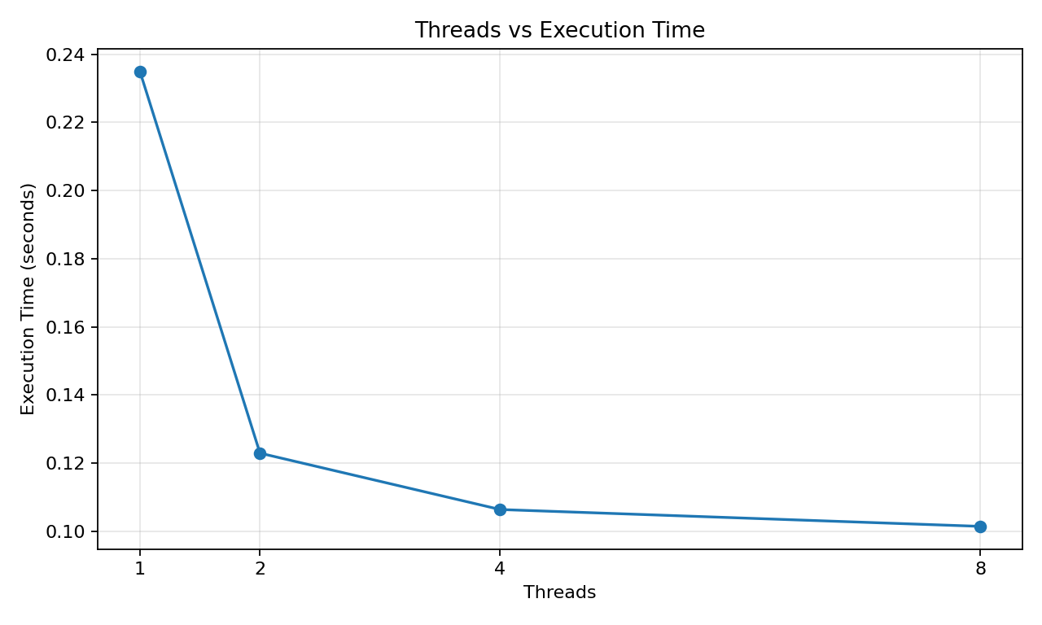
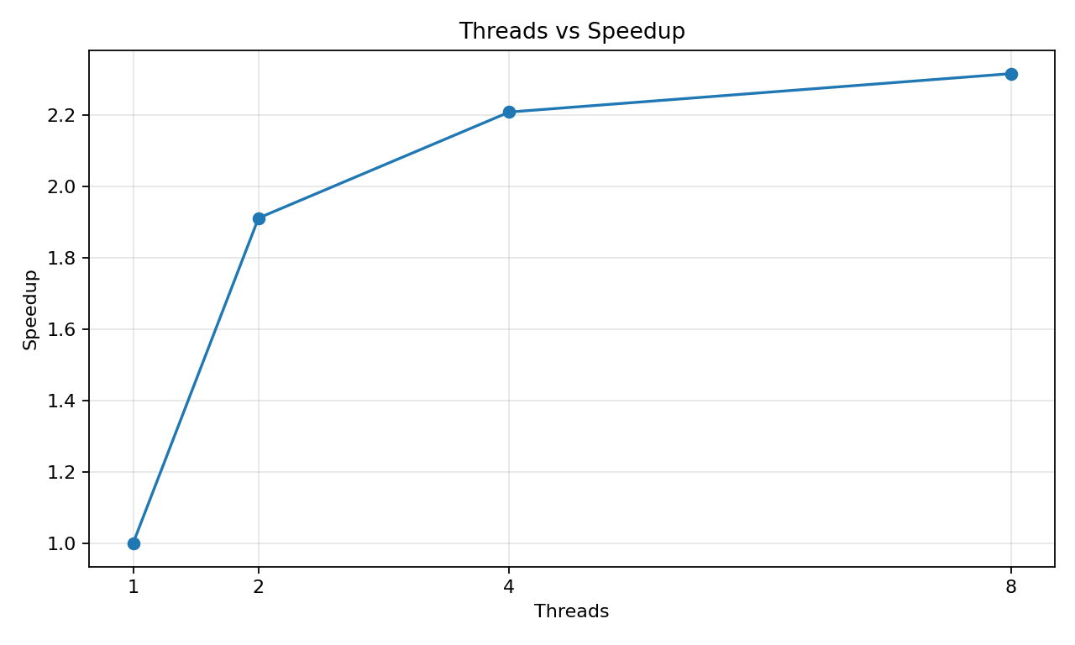
Note: Parallel execution is not guaranteed to become faster for every thread count. Thread creation, scheduling, memory bandwidth and system load can reduce or even reverse the expected speedup.

Section C — Challenge 1: Parallel Merge Sort
The experiment allows Parallel Merge Sort, Parallel Quick Sort or Recursive Matrix Multiplication. This solution selects Parallel Merge Sort because it is simple to understand. The sheet asks to explain recursive decomposition, task creation and how recursion enables parallel execution. fileciteturn1file0L86-L96
// ---------- Challenge 1: Simple Parallel Merge Sort ----------
void mergeParts(vector<int>& a, int l, int m, int r) {
vector<int> temp;
int i = l, j = m + 1;
while (i <= m && j <= r) {
if (a[i] <= a[j]) temp.push_back(a[i++]);
else temp.push_back(a[j++]);
}
while (i <= m) temp.push_back(a[i++]);
while (j <= r) temp.push_back(a[j++]);
for (int k = 0; k < (int)temp.size(); k++)
a[l + k] = temp[k];
}
void mergeSortParallel(vector<int>& a, int l, int r, int depth = 0) {
if (l >= r) return;
int m = (l + r) / 2;
// Only first two levels are parallel to keep the example simple.
if (depth < 2) {
#pragma omp parallel sections
{
#pragma omp section
mergeSortParallel(a, l, m, depth + 1);
#pragma omp section
mergeSortParallel(a, m + 1, r, depth + 1);
}
} else {
mergeSortParallel(a, l, m, depth + 1);
mergeSortParallel(a, m + 1, r, depth + 1);
}
mergeParts(a, l, m, r);
}
Simple explanation: Merge sort divides the array into a left half and a right half. These two halves can be processed independently. OpenMP sections allow the two recursive calls to execute in parallel. After both halves are sorted, they are merged.

Challenge Output
The program sorts: 9 4 7 2 8 1 6 3 5 0
Expected sorted result: 0 1 2 3 4 5 6 7 8 9

Section D — AI/HPC Case Study: Computer Vision
The supplied sheet asks for one domain and a 300–500 word report covering decomposition strategy, suitability, scalability and the choice of OpenMP/MPI/CUDA/hybrid. fileciteturn1file0L116-L128
Computer vision systems process large images and video frames. A common decomposition strategy is data decomposition, where an image is divided into rows, columns, tiles or independent regions. Each processing unit performs similar operations on its assigned region. This is suitable because many pixel operations do not depend on distant pixels, allowing multiple regions to be processed simultaneously. For example, image filtering can divide an image into blocks and apply the same filter to each block. This creates a large amount of parallel work and improves scalability when the image size increases.
For a CPU-based implementation, OpenMP is a simple and effective choice because threads share the same memory and can process different image regions without explicit message passing. For a distributed-memory system containing multiple machines, MPI would be more suitable because each process can own part of the image and communicate boundary information. For GPU-based computer vision, CUDA is often preferred because GPUs provide massive data parallelism and high memory bandwidth. A hybrid MPI + CUDA approach can be used for very large systems containing multiple GPU-equipped nodes.
Decomposition also affects cache locality. Dividing work into contiguous rows or 2D tiles can allow a processor to reuse nearby data efficiently. Poor decomposition can cause threads to access memory inefficiently and can increase communication or synchronization overhead. Therefore, the best strategy depends on the hardware and algorithm. For simple CPU image processing, row-wise data decomposition with OpenMP is easy to implement and understand; for high-performance GPU processing, 2D block decomposition is often more appropriate.

Answers to Final Questions
1. Which decomposition strategy gave the best performance? Why?
Answer: For the simple matrix multiplication implementation, row-wise output decomposition is a strong choice because each thread receives independent rows and the workload is naturally balanced.
2. How does decomposition influence scalability?
Answer: Good decomposition creates enough independent work, balances the workload and improves memory locality. Poor decomposition creates idle threads, synchronization or memory-access overhead.
3. Which decomposition would you use for distributed-memory systems?
Answer: Output/data decomposition or block decomposition is suitable because separate portions of the data can be assigned to different processes and exchanged when necessary.
4. Which strategy is most suitable for GPUs?
Answer: 2D block decomposition is generally suitable because GPUs can process many blocks/tiles concurrently. The exact best choice depends on the algorithm.
5. Can one problem be solved using multiple decomposition strategies?
Answer: Yes. Matrix multiplication can be divided by rows, columns or 2D blocks. The same image-processing problem can also be divided by rows or tiles.

Result
The matrix-vector and matrix-matrix sequential and parallel versions produce the same results, confirming correctness. The output also demonstrates row-wise and column-wise decomposition and a simple recursive parallel merge sort. The performance section shows how execution time and speedup change with thread count.

Conclusion
This experiment demonstrates how matrix problems can be divided into smaller independent pieces using OpenMP. Row-wise decomposition is the simplest approach for matrix-vector and matrix-matrix multiplication because each thread can work on separate output rows. Recursive decomposition is useful for algorithms such as merge sort. The main lesson is that decomposition determines how much parallel work is available, how well the workload is balanced and how efficiently the CPU can access data.

